# **Special Topics** (CSE 490-R)

## Handoff Check List – Week 13-14 Sprint

|  |  |
| --- | --- |
| **Date of meeting**:  **Instructor:**  **Student:** | July 20, 2022  Bro. Clements  Guillermo Oliva |

**Part 1: Documentation Up to date**

Determine the status of the feature(s) that you have worked on, update the information, documentation and any other items.

* Is the requirements document up today?
  + YES
* Is the design document up to date?
  + YES
* Is the test plan up to date?
  + YES
* Is the software development guide up to date?
  + YES
* Is the installation guide up to date?
  + YES
* Is the user guide up to date?
  + YES

**Part 2: Check-in everything**

Make sure you have merged, checked in, and upload all your changes.

* YES, everything merged, checked in, and uploaded

Provide a screen shot of your GitHub Desktop to make sure you have uploaded everything.

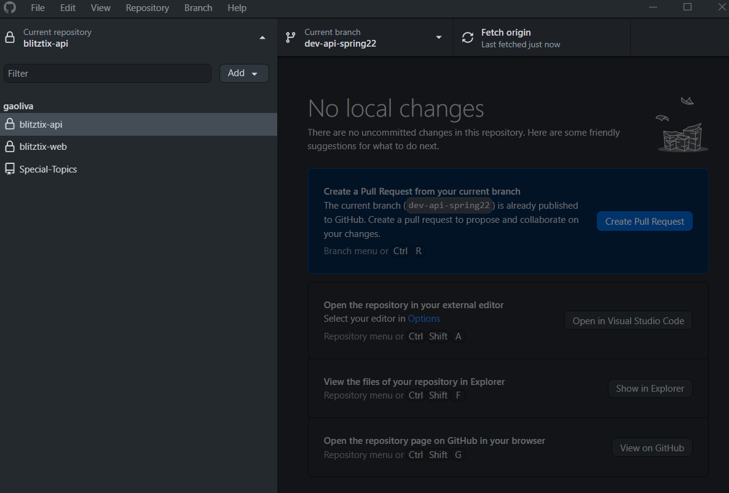

**Part 3: Personal Portfolio**

Is your personal GitHub account checked in?

YES, this is the link to my personal folder: <https://github.com/gaoliva/Special-Topics>